Setting up Your Account Using a Class Enrollment Key
If you are new to Turnitin and have not been added to an account by your instructor, you must create a student profile. To create your own student account, your class ID and class enrollment key are required.

Note: The class ID and class enrollment key is needed to ensure you have authorization to join a class, and can only be obtained from your instructor. Students wishing to access Turnitin must contact the appropriate personnel at the institution to receive the class ID and class enrollment key. Turnitin staff cannot distribute this information to any user.
Instructors may distribute this data or may add students to a Turnitin class themselves, which will send an automatic welcome email, allowing access to the account.

1. Go to www.turnitin.com and click on the Create Account link next to the Log In button

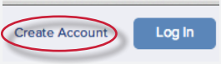

2. Click on student link

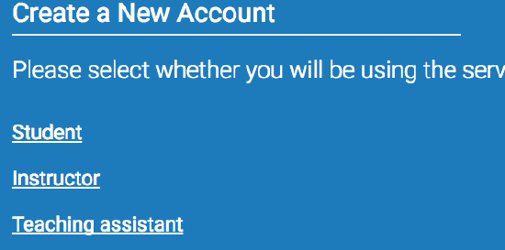
3. The Create a New Turnitin Student Account form must be completed to create a new student user account

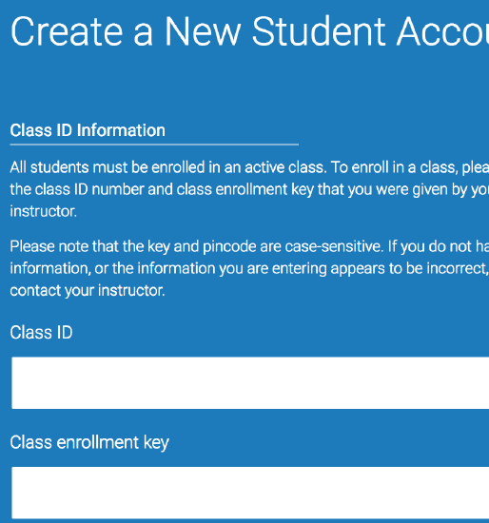

4. Enter the class ID number and the case sensitive Turnitin class enrollment key

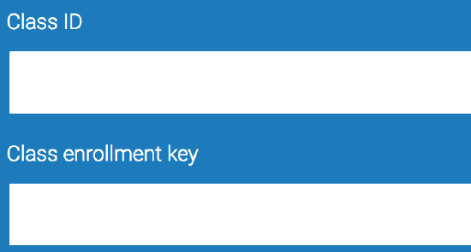

5. Enter the user first name, last name, and a valid e-mail address to use as the login for Turnitin

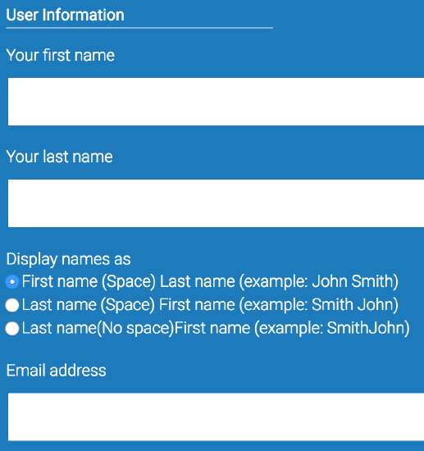
6. Create a user password. The user password must be between six and twelve characters long and contain at least one letter and one number. Re-enter the password to confirm it

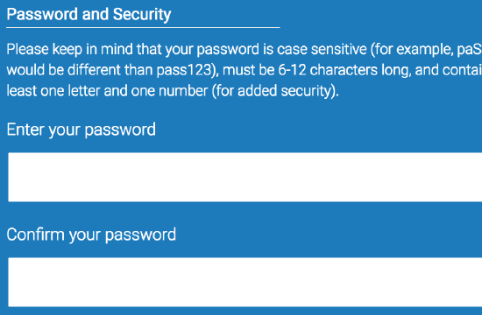

7. Select a secret question from the drop-down menu. Enter the answer for the question. Remember and keep this information. The answer is case and space sensitive

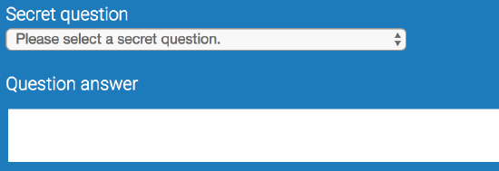

8. Review the user agreement. To continue using Turnitin, click on I agree -- create profile
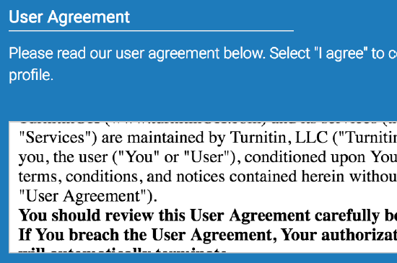

10. From the completed user profile creation page, click on Log in to Turnitin

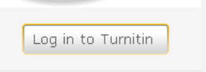

Note: If step 6 indicates that the e-mail provided is already in Turnitin, there is an existing profile under the e-mail you entered. Please use the Resetting Your Password instructions, if the password has been forgotten, to gain access to the user profile if you had a previously existing Turnitin user profile, or use an alternate e-mail address for your Turnitin access.

